
Minutes of the AGM held at Mark Masons’ Hall
86 St James’s London at 6.30pm on 1st February 2022

Present
Committee
Iain Stevenson – Captain
Vice-Captain - Jason Wood
Nick Archer – Treasurer
Neil Meixner – Secretary
Ken Adams – President / Deputy Secretary
Ben Hurworth - Committee
Darrell Lewis – Committee
Neil Blundy – Committee / Past Captain
Rob Seeley – Committee

Additionally, members in attendance were: - Ian Abley, Steven Barker, Joel Evans, Martin Howie, Richard Hunt, Matthew Jones, Delwyn Jacobs, Stewart Kirkwood, Aidan Mahoney, Jarlath Rooney, Michael Salmon, Christopher Sunderland, Michael Trott, David Wannerton and Fiona Watson.
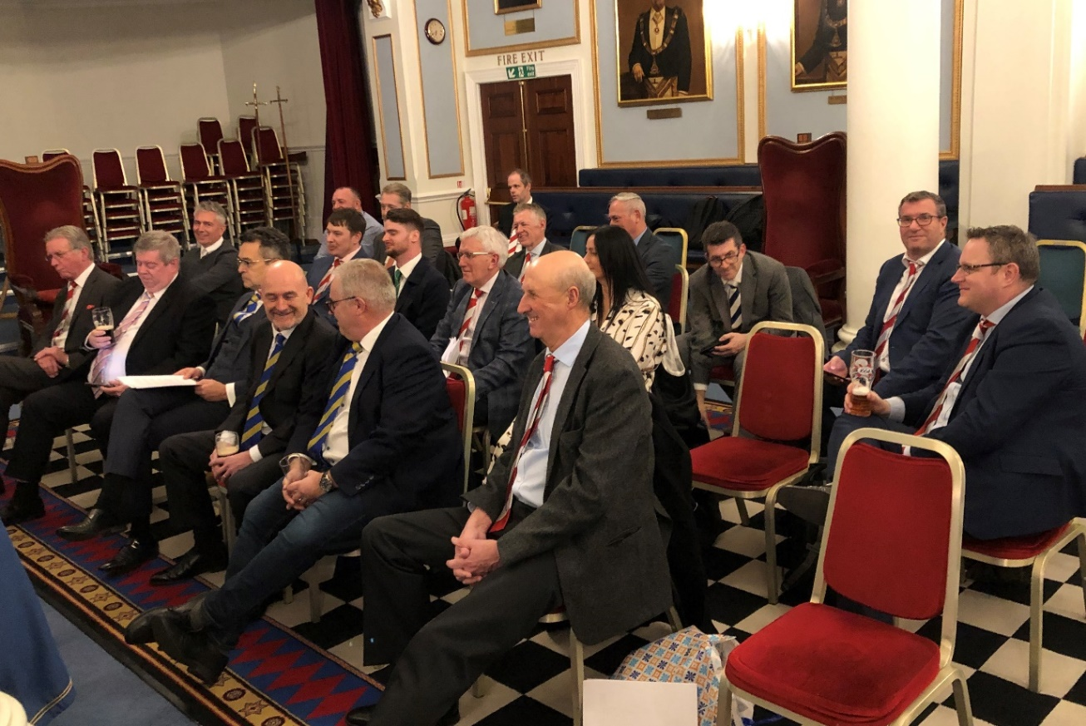
Apologies were received from Chris Anderson, James Barrett, David Bennett, John Biscoe, John Bush, John Campbell, Jon Coles, Gary Dann, Steve Davies, Michael Foster, Steve Haley, Digby Hebbard, Graham Howe, Steve Hurworth, Paul Ibson, Jeff Lewis, John Marsh, Malcolm Marshall, Bill Merry, Adrian Pitt, Oliver Tobin and Gavin Tuck

The Secretary opened the meeting at 6.35

- Minutes of Previous Meeting

The minutes of the previous AGM held on 11th February 2021 were unanimously agreed.

- Matters arising

The Secretary noted that the Martyn Rowlands Hole in one Trophy mentioned above was duly presented to both Steven Barker and Jason Wood at Moor Park in the spring of 2021

- Captain’s Report

The Captain delivered the whole of his report verbatim. If you’d like to see it all use this link! Captains Report

- Secretary’s Report

The Secretary offered his report as read, highlighting only that members were encouraged to put the event dates in their diary now and make every effort to attend as many events as possible.

- Treasurer’s Report & Accounts

The treasure offered the Balance Sheet as issued but outlined the following key messages.
  - Charity donation made to Rosie’s Rainbow totalled £6775 over the 4 years of Ken Adams’s Presidency.
  - Turnover for 2021 was up to £5225 for the 6 events, up from 4 in 2020.
  - Profit on the year £1408

- 2022 Subscription

Michael Salmon proposed, seconded by Aidan Mahoney, that the annual subscription remain at £50 and carried unanimously.

Members are reminded to send their payments to Nick Archer as soon as possible and to annotate them so we know what they were for and where they came from

- Membership

Membership stands at 65 but will be subject to review status of a number who have overdue subscriptions from 2021. The Secretary informed the meeting of the 11 new members in 2021/2 namely, James Barrett, Richard Bartholomew, Callum Howie, Paul Ibson, Delwyn Jacobs, Adrian Pitt, Richard Poulter, Jarlath Rooney, Bradley Taylor, Danny Toseland and Robert White. The meeting welcomed them all. The Secretary pointed out that Martyn Howie had recruited the majority of these and thanked him for his efforts.

Following on from this success ALL members should endeavour to introduce at least one, preferably young, new member to the Society.
- Appointment of Officers and Committee

The Committee proposed that the officers for 2022 be as follows: -

Jason Wood – Captain
Rob Seeley - Vice-Captain
Nick Archer – Treasurer
Neil Meixner – Secretary
Ken Adams – President / Deputy Secretary
Malcolm Marshall – Committee / Deputy Treasurer
Darrell Lewis – Committee
Neil Blundy – Committee
Iain Stevenson – Committee / Past Captain
Fiona Watson - Committee

The appointment of the Officers and Committee was proposed by Steven Barker, seconded by Matthew Jones and carried unanimously. Ther secretary informed the meeting that Ben Hurworth was standing down after serving for many years and he was thanked for all he had done.

- New Captains thoughts and Tour Update

Jason Wood was enthusiastic about his year and particularly highlighted his desire to defeat the BAGS in the forthcoming annual clash this year to be held at Thorndon Park. He also confirmed that 28 members were touring to Vilamoura from 9-12 September. There is an opportunity to play additional golf on the Friday and Tuesday if tourists wish and Jason undertook to send details to tourists after the meeting

- Charity Day – Moor Park – 29th June 2022

Steven Barker outlined the progress so far and detailed £5k sponsors from Franchi Group & EH Smith. A number of Auction prizes had been donated and Steven asked if anyone had anything to offer up in this regard. All were encouraged to attend and indeed bring guests with deep pockets. The Secretary reminded all that it was £150 per person for the day.

- 2022 Programme

The Secretary noted the 2022 programme had been issued to all. For the sake of good order here is a link to Programme 2022

Please put these dates in your diaries.
- President’s Comments

Ken Adams thanked all for their continued support and reiterated that EPIC had raised a magnificent £6775 to date during his tenure. The drive to raise a huge amount for both the Captain’s Charity and Rosie’s Rainbow fund was helped as stated previously by Mr Barker by the £5k donations from the two named previously. The President expressed the desire to get another £5k sponsor!! The President further asked all at the AGM to try and get donations from their colleagues, suppliers, or fellow professionals. He also reminded all that it had been a challenge for so many charities during COVID and their need for financial help had not diminished. He reiterated thanks to all for their support.
- AOB

The Secretary raised the following items for consideration

  - Change to the Rules
    - It was proposed by Iain Stevenson and Seconded by Neil Blundy that “A Notice of the AGM is to be issued to all members of the Society together with supporting papers 28 days prior to the meeting. Members who wish to raise items must give written notice to the Secretary 14 Days prior to the meeting” should be amended to 14 and 7 days respectively and carried unanimously.
    - For the sake of good order, it was proposed by Steven Barker and seconded by Ken Adams that “Committee meetings shall be held regularly during the currency of the year to implement the wishes of the members as agreed at the AGM and a quorum of members must attend.” should be construed to apply to virtual/electronic meetings just as well as those undertaken in person, which was carried unanimously.
    - Neil Blundy proposed, seconded by Darrell Lewis that “Every 5 years a President shall be nominated by committee and approved by the AGM.” be amended to “Every 5 years the outgoing President shall nominate his successor which is to be put to the next AGM for approval.” This amendment was carried unanimously.
  - The meeting decided unanimously that Fiona Watson should determine an appropriate item to be worn by lady members in lieu of ties.

There being no further business, the meeting was closed at approximately 19:45.

Awards for the 2021 Season
Following the meeting replica trophies were presented to all winners present
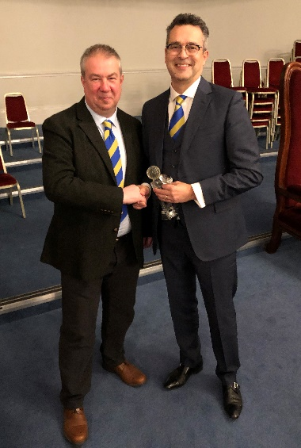
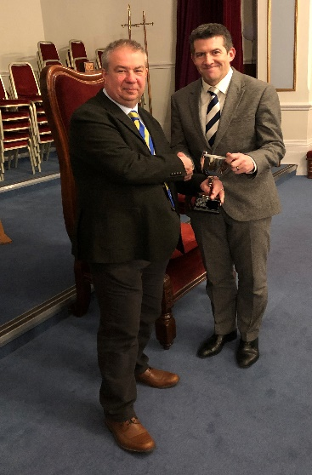
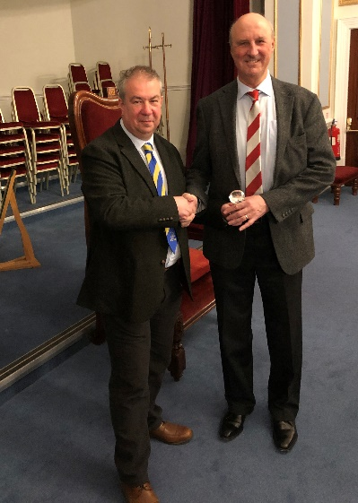
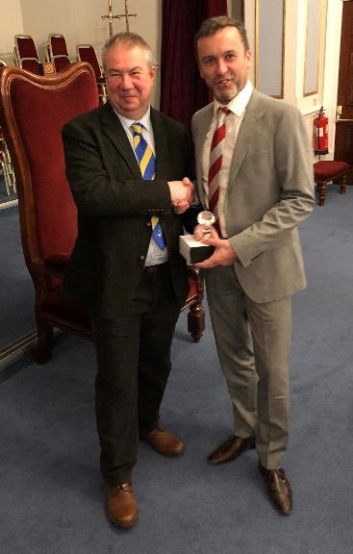
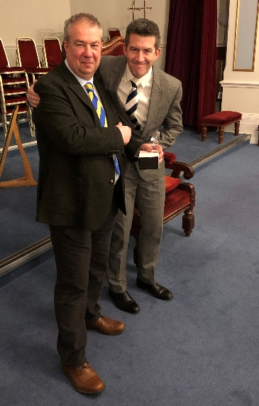
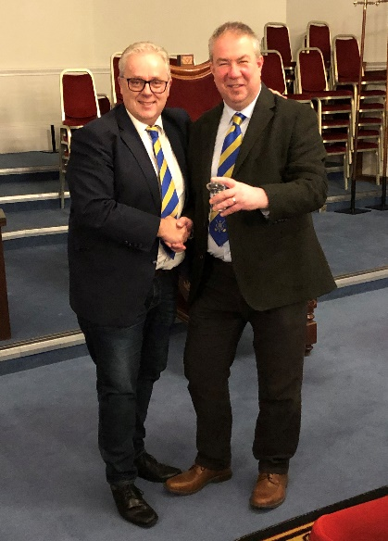
Matthew Jones Player of the Year
Iain Stevenson Bush Trophy
Jarlath Rooney President's Cup
Matthew Jones Captain's Cup
Neil Blundy Spring Cup
Ben Hurworth Jubilee Cup

